OPERATING SYSTEM ASSIGNMENT - 1

Name: Deepika Rani
Roll No: 2401201131
Course: BCA (AI & DS)
Subject: Operating System
Assignment 1: CPU Scheduling Algorithms

1.INTRODUCTION
CPU Scheduling is an important concept in Operating Systems that determines which process will be executed by the CPU at a given time. It helps in improving CPU utilization and system performance.
In this assignment, we implemented two scheduling algorithms: First Come First Serve (FCFS) and Shortest Job First (SJF) using Python.

2.OBJECTIVE
In this task, we created a Process class to store process details such as Process ID, Arrival Time, and Burst Time. User input was taken for multiple processes and stored in a list.

3.TASK 1: PROCESS CREATION
In this task, we created a Process class to store process details such as Process ID, Arrival Time, and Burst Time. User input was taken for multiple processes and stored in a list.
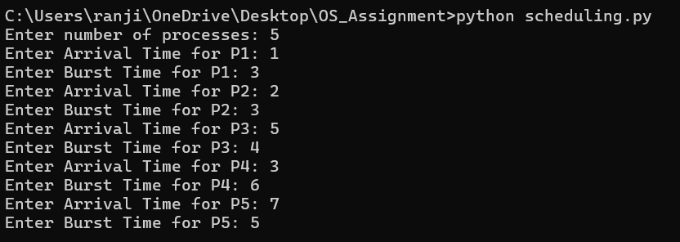

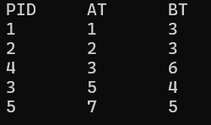

4.TASK 2: FCFS SCHEDULING
First Come First Serve (FCFS) is the simplest CPU scheduling algorithm. In this method, processes are executed in the order in which they arrive.
Completion Time (CT), Turnaround Time (TAT), and Waiting Time (WT) are calculated using standard formulas.
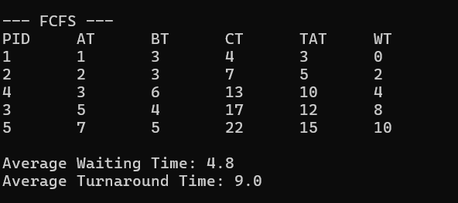

5.TASK 3: SJF SCHEDULING
Shortest Job First (SJF) scheduling selects the process with the smallest burst time among the available processes.
This algorithm helps in reducing the average waiting time and improves system efficiency compared to FCFS.
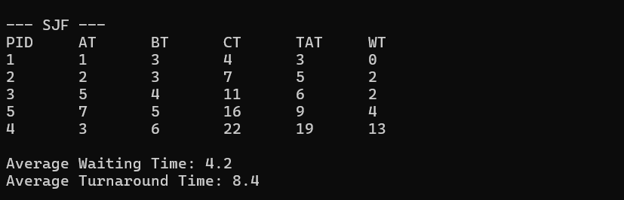

6.TASK 4: GANTT CHART
Gantt Chart represents the execution order of processes along with their time intervals.
FCFS:
| P1 | P2 | P4 | P3 | P5 |
0 4 7 13 17 22
SJF:
| P1 | P2 | P3 | P5 | P4 |
0 4 7 11 16 22

7.TASK 5: PERFORMANCE ANALYSIS
From the results, it is observed that SJF gives better performance compared to FCFS as it reduces the average waiting time and turnaround time.
However, SJF may cause starvation for longer processes.

